Christ Presbyterian Church

New Haven

...so that He might come to have first place in all things.
Colossians 1:18

Christ Presbyterian Church
Servant Leaders

ELDERS

Name | Office | Home | Email
Preston Graham, Jr. | 777-6960 | 315-5041 | cpc.preston@snet.net
George Levesque | 432-8977 | 697-2123 | george.levesque@yale.edu
Alan Phillips | 212-573-3822 | 834-2427 | alan.phillips@pfizer.com
Robert Hawkes | 203-406-8385 | 380-9855 | Rhawkes@kpmg.com
Joe Shields (Apprentice) | 777-6960 | 387-7496 | cpc.joe@snet.net
Doug Bruce (Apprentice) |  | 687-8226 | Robert.bruce@yale.edu

SERVANT LEADER BOARD

Name | Telephone
Gary & Rebecca Bach | 272-5574
Jennifer Cheng | 457-9825
Evan Finch | 288-1019
Lisa Graham | 315-5041
Katie Levesque *Secretary  klevesque@choate.edu | 697-2123
Name | Telephone
Fran Onofrio | 387-8715
Gary Wininger | 736-6219
Steve Woolbert | 375-1414

NEIGHBORHOOD BIBLE STUDIES

Area | Group Leaders | Telephone | Email
Hamden/Cheshire | Victor Patin | 230-9299 | addmd@prodigy.net
Westside/ Trumbull | Gary Wininger | 736-6219 | garywininger@hotmail.com
Graduate Student/  Young Professional | Tolivar Wills | 777-6960/288-9169 | cpctolivar@snet.net
Shoreline | Cliff Bogue | 453-8719 | clifford.bogue@yale.edu
Westville One | Vince Calhoun & Doug Bruce | 397-3112/687-8225 | vince.Calhoun@ yale.edu  robert.bruce@yale.edu
Westville Two | Joe Shields & Evan Finch | 387-7496/288-1019 | joseph.shields@aya.yale.edu  evan.finch@yale.edu
New Haven-Mansfield  New Haven-East Rock | Larry Jorgensen  Dan Cantey | 230-0483  436-3449 | larry.Jorgensen@yale.edu  dan.cantey@yale.edu

CHRIST PRESBYTERIAN CHURCH / PCA

Statement of Identity

Christ Presbyterian Church, New Haven, is a member of the Presbyterian Church in America (PCA). As one of many communions in the church universal, the PCA may be distinguished by its affirmation of what has been described as the “Reformed system of faith” as reflected in the Westminster Confession of Faith. The PCA is characterized by its emphasis on both personal revival and theological reformation. Without revival, reformation can become “dead orthodoxy.” Without reformation, revival can result in shallow experientialism and misinformed zeal. By promoting reformation and revival, we seek to carry out the Great Commission with biblical integrity and personal authenticity unto the glory of God.

Five Basic Commitments

- We are committed to the Old and New Testament Scriptures as our only rule of faith and practice.

While believing that God powerfully manifests His infinite glory in a general way through creation, our Christian faith and practice is grounded in God’s works of redemption in history as explained to us through the divinely appointed means of inspired Scripture. We believe that all things necessary for salvation are sufficiently revealed to us by the Holy Spirit speaking through the Scriptures of the Old and New Testaments. We believe also that all special revelation has ceased until the next and final redemptive act of God in history when Christ will return to judge the living and the dead. It is, therefore, our ambition to teach the whole counsel of God’s word, not adding to, or subtracting from, anything contained within it, recognizing no other source for divine revelation, whether by ecclesiastical traditions or private revelations.

- We are committed to the teachings of grace as they are summarized in the historic Westminster Confession of Faith.

Whereas the Holy Scriptures are our only rule of faith and practice, our Church unity is predicated upon a consensus about what the Scriptures principally teach. Our consensus is reflected in the 350–year-old Westminster Confession of Faith. In summary, it affirms that God is no less sovereign in our salvation than He is sovereign in our creation to the praise of God’s glorious grace! This means that we are accepted by God, from beginning to end, not by our own works or attempts at being approved by God, but by faith alone in the perfect and all sufficient work of Christ on our behalf, faith itself being the free gift of God! While many people join our church without knowing or affirming all the teachings contained in the Westminster Confession of Faith, our church, when acting and speaking corporately, seeks to be in accord with the Westminster Standards.

3. We are committed to God-centered worship designed after a covenantal pattern that is in the mediated presence of Christ through word and sacrament.

In every period of redemptive history, God has chosen to mediate His saving presence among His people as regulated through the divine institutions of word, sacrament, and prayers. Today, through the sacraments of the Lord’s Supper and Christian Baptism, together with the preaching of God’s word and corporate prayers (both sung and unsung), God has promised to be with us until the end of the age. Our worship is set to the pattern of covenant initiation and renewal including the weekly participation in the Lord’s supper. Our music and style of worship is “blended” to reflect the vernacular context of those God has brought to our city. Our desire is for our worship to be as God-centered as our theology, communicating the truth and grace of God to the nations. We welcome all believers together with those who are searching.

4. We are committed to being a multi-cultural church and church planting movement.

We believe that the church, the household of God, is an essential element of the gospel into which people of every tribe and nation are welcomed. While affirming that every follower of Christ is called to be a witness to the truth and grace of God revealed in Jesus Christ in both word and deed, we also believe that true evangelism is best accomplished through church planting. It is therefore our ambition not to be only a growing church, but also a growing church planting movement. While holding to a time-honored understanding of faith, we are strategically progressive. Our aim is to plant churches that reach the different cultures in our city, Southern New England, and the world.

5. We are committed to a high view of Christian calling as reflected in the vocational spheres of family, church, and public
service.

We believe that God has placed into our lives the boundaries of our habitation that reflect His own sovereign design to accomplish His work in the world. His work extends into the spheres of family, church, and civil vocations. We desire to help people find a balance that is unique to their individual callings and that reflects a high view of vocation and calling in these three spheres of service. While believing that the Christian Scriptures do not address all things pertaining to life in this world, we do affirm that we should take “every thought captive to the obedience of Christ” and that the Christian worldview is applicable and relevant to all spheres of life. Our ultimate commitment is to the restoration of “calling” that we might more and more glorify God and enjoy Him forever!

The Mission of Christ Presbyterian Church
We are a church that is ambitious for the glory of God by
GROWING in the truth and grace of Jesus Christ,
ACTING as a faithful witness in the greater New Haven community and world,
TRUSTING in the grace and power of the Holy Spirit.

STAFF

Position | Name | Telephone | Email
Senior Pastor | Preston Graham | 777-6960 | cpc.preston@snet.net
Assistant Pastor  Worship Director | Tolivar Wills  Joe Shields | 777-6960  777-6960 | cpctolivar@snet.net  cpc.joe@snet.net
Administrative Assistant | Ilona McGowan | 777-6960 | cpc.ilona@snet.net
Assistant to Sunday  Ministries | John Hardie | 495-9253 | jhardie@juno.com
Campus Ministry | Clay Daniel | 777-6960 | cpc.clay@snet.net

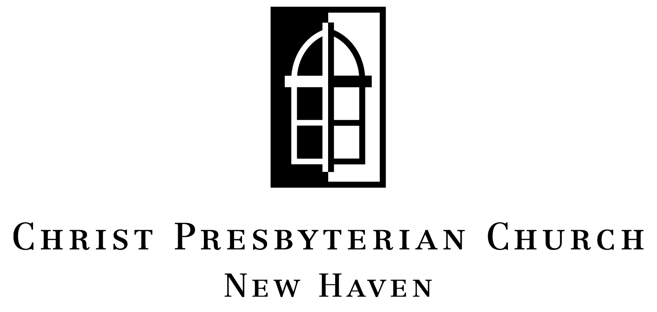
Office/Study Center
135 Whitney Ave. * New Haven, CT 06510-1245
203.777.6960 www.christpresnewhaven.org

